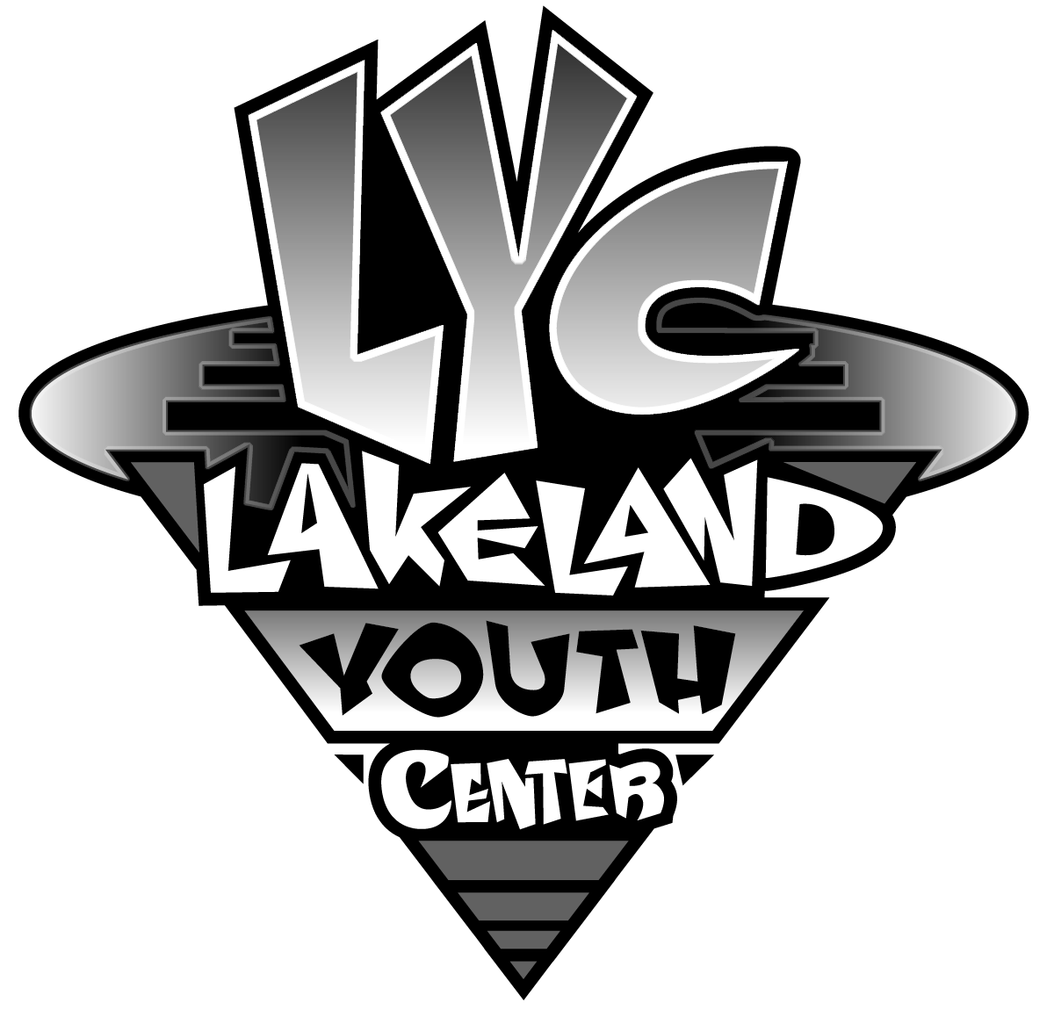

C:\Users\Office\AppData\Local\Microsoft\Windows\Temporary Internet Files\Content.IE5\RUMRC9IK\MC900047809[1].wmfC:\Users\Office\AppData\Local\Microsoft\Windows\Temporary Internet Files\Content.IE5\RUMRC9IK\MC900047809[1].wmfC:\Users\Office\AppData\Local\Microsoft\Windows\Temporary Internet Files\Content.IE5\RUMRC9IK\MC900047809[1].wmfC:\Users\Office\AppData\Local\Microsoft\Windows\Temporary Internet Files\Content.IE5\RUMRC9IK\MC900047809[1].wmfC:\Users\Office\AppData\Local\Microsoft\Windows\Temporary Internet Files\Content.IE5\RUMRC9IK\MC900047809[1].wmfC:\Users\Office\AppData\Local\Microsoft\Windows\Temporary Internet Files\Content.IE5\RUMRC9IK\MC900047809[1].wmfC:\Users\Office\AppData\Local\Microsoft\Windows\Temporary Internet Files\Content.IE5\RUMRC9IK\MC900047809[1].wmf

Lakeland Youth Center (LYC) is a not-for-profit organization created to meet the needs of the youth in our community. Since opening its doors over 50 years ago the LYC has been instrumental in preparing children, academically, socially and physically for life. Our most recognized programs are the LYC Preschool and our soccer programs. The preschool is consistently regarded as the best program in our area and our spring and fall soccer programs bring hundreds of participants to the soccer fields each season. LYC programs impact the lives of over 1200 area youth each year!

Other LYC programs include seasonal craft classes, flag football, basketball, middle school dances, cheerleading and community wide family programs such as Holiday Magic, Breakfast with Santa, Fall Carnival and the Daddy Daughter Dance! LYC strives to help develop the lives of our youth by giving them the resources and knowledge to not only enhance their future, but our communities as well.

In a constant effort to support our ever evolving young adults, the LYC would like to offer a $1000 college scholarship to a Wawasee male and female senior graduating in 2020. Applicants are required to use the Wawasee Scholarship application and have it submitted to the LYC by May 1, 2019. <http://www.wawasee.k12.in.us/education/components/docmgr/default.php?sectiondetailid=9118&fileitem=4476&catfilter=ALL> Once chosen, these recipients would be required to volunteer 35 hours of their time with the Lakeland Youth Center from June 1st, 2019 - April 30, 2020 to be eligible for the scholarship presented at the end of the school year. Potential volunteer time includes, but is not limited to the above stated programs and will be arranged with the Executive Director.

Applications can be submitted by:

* Mail (PO Box 201, Syracuse)
* Email (lakelandyouthcenter@gmail.com)
* LYC drop box (101 W Chicago St, Syracuse)

Please feel free to contact us with any questions or concerns.

C:\Users\Office\AppData\Local\Microsoft\Windows\Temporary Internet Files\Content.IE5\RUMRC9IK\MC900047809[1].wmfC:\Users\Office\AppData\Local\Microsoft\Windows\Temporary Internet Files\Content.IE5\RUMRC9IK\MC900047809[1].wmfC:\Users\Office\AppData\Local\Microsoft\Windows\Temporary Internet Files\Content.IE5\RUMRC9IK\MC900047809[1].wmfC:\Users\Office\AppData\Local\Microsoft\Windows\Temporary Internet Files\Content.IE5\RUMRC9IK\MC900047809[1].wmfC:\Users\Office\AppData\Local\Microsoft\Windows\Temporary Internet Files\Content.IE5\RUMRC9IK\MC900047809[1].wmfC:\Users\Office\AppData\Local\Microsoft\Windows\Temporary Internet Files\Content.IE5\RUMRC9IK\MC900047809[1].wmfC:\Users\Office\AppData\Local\Microsoft\Windows\Temporary Internet Files\Content.IE5\RUMRC9IK\MC900047809[1].wmf

Lakeland Youth Center

PO Box 201

Syracuse, IN 46567  
574.457.3055  
[Lakelandyouthcenter@gmail.com](mailto:Lakelandyouthcenter@gmail.com)

www.lakelandyouthcenter.com